Watch Me Grow Academy
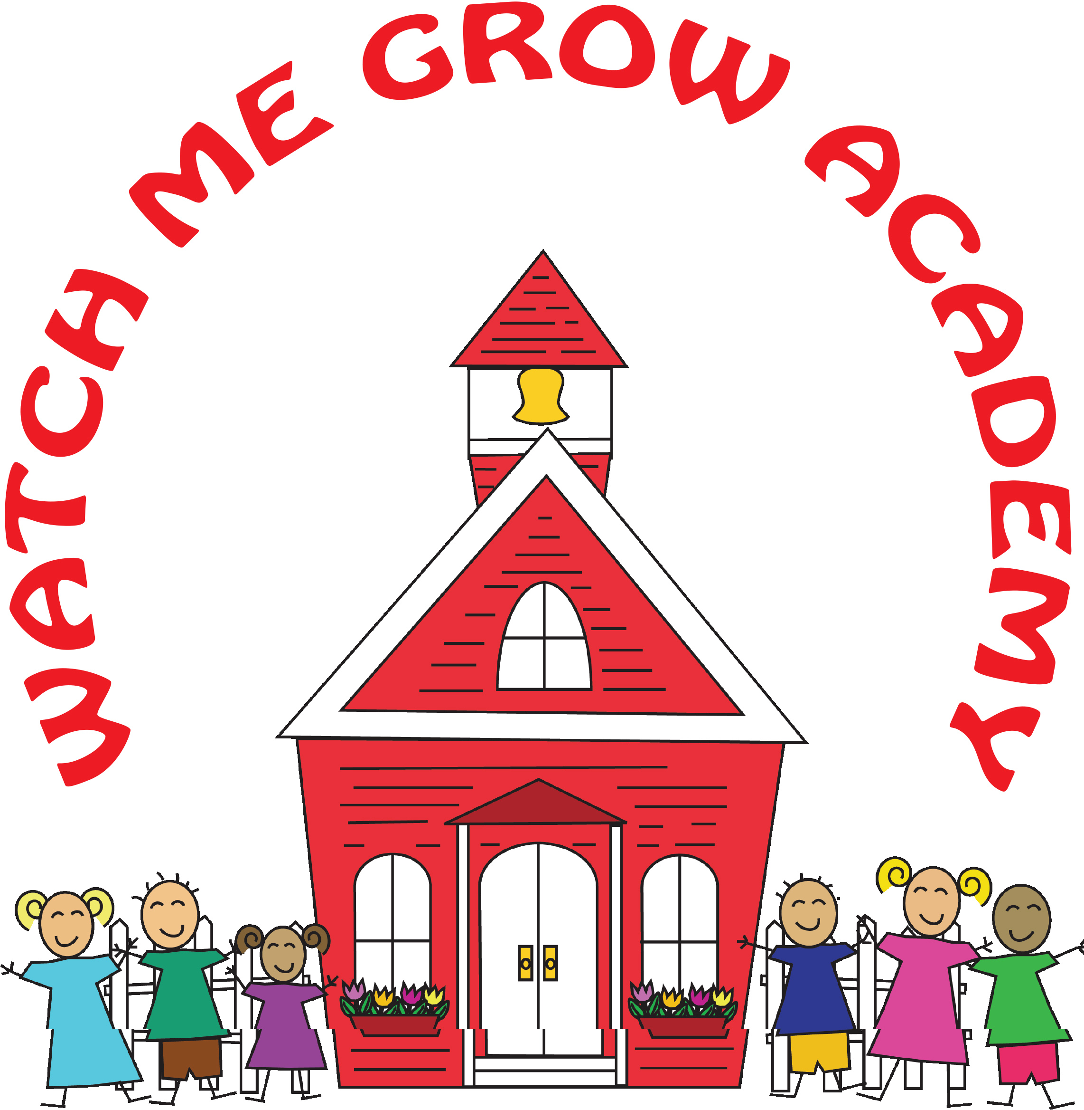
3 Marshall Street Store #7
Irvington, NJ 07111
862-231-6348 (Fax) 862-231-6349

2022-2023 School Closing
And Early Dismissal
Dates | Reason
10/10/22 | Closed for Indigenous People Day
10/20/22 | 1:00PM Dismissal  Staff Development
11/23/22 | 1:00PM Dismissal  Family Lunch at 12:00-1:00
11/24/22 | Closed for Thanksgiving
11/25/22 | Closed for Black Friday
12/7/22 | 1:00PM Dismissal  Staff Development
12/23/22 | 1:00PM Dismissal
12/26/22-12/30/22 | Closed for Winter Break
01/02/23 | Closed for New Year’s (Observed)
01/16/23 | Closed Dr. Martin Luther King Jr. Day
02/16/23 | 1:00PM Dismissal  Staff Development
03/15/23 | 1:00PM Dismissal  Staff Development
04/19/23 | 1:00PM Dismissal  Staff Development
05/29/23 | Closed for Memorial Day
06/19/23 | Closed for Juneteenth
07/03/23-7/04/23 | Closed for July 4th
08/28/23-9/1/23 | Closed for Summer Break
09/04/23 | Closed for Labor Day
09/5/23 | Closed for Staff Development

