Watch Me Grow Academy
Resources
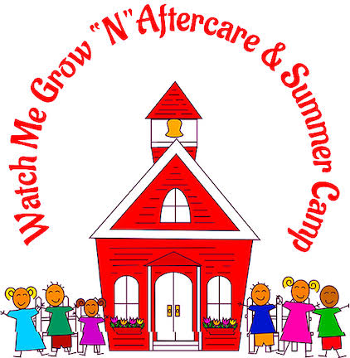
Table of Contents
Behavioral Health 5
Intellectual and Developmental Disability Services 5
Applying for eligibility 6
• Care Management Organizations 7
Outpatient Mental Health And Substance Use Counseling 12
School-Based Youth Services Program (SBYSP)/The Imani Center 14
Counseling and Mental Health Services 14
COVID-19 Support 15
Academic Support 15
Community Engagement 16
The Peace Model Project 17
Family Preservation Services 19
Stepping Stones 20
How CFBNJ Helps Hungry Neighbors 23
Emergency Rescue Mortgage Assistance Program (ERMA) 28
County and City Rental Assistance Programs May Help 28
Tenants Know your Rights 31
Free Counseling Available to Homeowners and Renters 31
Housing Help NJ 32
RELATED PAGES 32
CONTACT INFORMATION 34
OFFICE HOURS: 34
Ensuring That Children And Families Receive High Quality Services In The Areas Of Health, Safety And Child Development. 35
Programs For Parents trainers have all met the Approved Trainer qualifications required for the Professional Impact New Jersey Registry by the NJ Workforce Registry. 35
We Will Do It Together! 36
American Rescue Plan (ARP) 39
New Jersey Universal Service Fund (USF) 41
New Jersey Lifeline for Seniors and Disabled Adults 43
NJ 2-1-1 Partnership 44

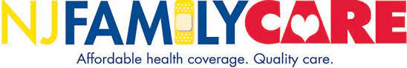

NJ Family Care
What is it?
NJ Family Care is federal, and state funded health insurance program created to help qualified New Jersey residents of any age access to affordable health insurance. NJ Family Care is for people who do not have employer insurance.
If you are interested in enrolling in NJ Family Care, please look at the Who Is Eligible? section to see if you qualify.
The entire application process can be completed online.

What does it cover?
NJ Family Care is a comprehensive healthcare coverage program that provides a wide range of services:
- Doctor visits
- Eyeglasses
- Hospitalization
- Lab tests
- X-rays
- Prescriptions
- Regular check-ups
- Mental health
- Dental
- Preventive screenings
- Autism services
- Community doula services
- Help with personal care needs
Four of the Health Plans are available in all counties, one is available in all counties except Hunterdon. Depending on your family’s income, there may be restrictions on certain services.

Apply for NJ Family Care
https://njfc.force.com/familycare/quickstart
We strongly encourage you to Apply Online. This is the fastest and easiest way to apply.
When you apply online you can create an account which will allow you to:
- Save partially completed applications
- View submitted applications, and
- Receive future Medicaid notifications electronically
- If you have questions or need help filling out the application, call 1-800-701-0710 (TTY: 711) for assistance.

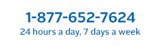
Perform Care

Behavioral Health
Perform Care partners with the New Jersey Children's System of Care (CSOC) to coordinate the care of your child. We are committed to helping children with behavioral, mental health, or emotional challenges gain access to the services they need.
Parents, family members, school employees, mental health providers and other professionals helping children and families can contact Perform Care on behalf of a youth in need of a referral. The parent or legal guardian of the child must still give consent for the child to receive services.
Find out more about behavioral health services available in New Jersey. If your child is currently experiencing a behavioral health crisis, please call us right away at 1-877-652-7624.
- Frequently Asked Questions (FAQs) for Families of Children with Behavioral Health Needs (PDF)Opens a new window
- Community resources.
- Family support organizations (FSOs).
- Fees and commercial insurance FAQs.
- Find a provider.
- Glossary and description of services.
- Suicide prevention - a call to action.

Intellectual and Developmental Disability Services
Children and youth with an intellectual or developmental disability and their families must meet service criteria set by state laws to access specialized services. For more details, go to the Applying for Determination of Eligibility webpage.

Applying for eligibility
Eligibility for developmental disability services are governed by state laws that define certain requirements that must be met. If you already applied and were determined eligible by the Division of Developmental Disabilities with an application submitted to them before January 1, 2013, you do not need to reapply.
Applying for Determination of Eligibility: Children up to Age 18
- Intellectual and Developmental Disability Services available through the NJ Children's System of Care Opens a new window (PDF)
  - Servicios para la discapacidad intelectual y del desarrolloOpens a new window (PDF)
- Family support servicesOpens a new window (PDF)
Certain caregivers of youth who have been determined eligible for developmental disability services may request support designed to help make caring for youth in the home and community easier.
  - Servicios de apoyo a la familiaOpens a new window (PDF)
Para las familias de los jóvenes elegibles para los servicios a las personas con discapacidades del desarrollo.
- Family support services assistive technologyOpens a new window (PDF)
  - Servicio de apoyo a la familia mediante la tecnologia asistencialOpens a new window (PDF)
- Summer camp assistance
Financial assistance is available to offset a portion of the cost of summer camp for certain youth.
Additional links from CSOC stakeholders
- Fight The Flu: It's Important To The Disability Community – From the Boggs Center on Developmental Disabilities Opens a new window (Added July 22, 2022)
- Getting a Flu Shot: A Social Story for People with Intellectual and Developmental Disabilities – From the Boggs Center on Developmental Disabilities (PDF)Opens a new window (Added October 28, 2020)
- The Revised Family Crisis Handbook Opens a new window (PDF)*
This handbook can assist you and your family with daily challenges, including overcoming barriers to care.
* Perform Care and the New Jersey Children's System of Care (CSOC) provide this information for your convenience. However, this document was not authored by Perform Care or CSOC. If you have questions or believe any of the information to be erroneous, please contact the document’s publishers.
Parents and Caregivers
- Emergency services and screening
- Eligibility
- Behavioral health
- Intellectual and developmental disability services
- Substance use treatment services
- Family portal Opens a new window
- Care Management Organizations
- Family Support Organizations
- Forms
- Frequently asked questions (FAQ)
- Glossary
- Guides and brochures
- Quick links
- Resources

Care Management Organizations
- Below is a listing of Care Management Organizations (CMOs) across New Jersey. CMOs are county-based, nonprofit organizations that provide face-to-face care management for youth with complex needs and their families.
- The CMO coordinates the organization and delivery of services through the Child/Family Team process and the wraparound approach to planning. They provide assessment and comprehensive planning for each youth and their family and develop strategies and supports that help youth maintain stability.
- Please note that prior authorization through Perform Care and the NJ Children's System of Care is required for CMO services. Call Perform Care at 1-877-652-7624 for more information on accessing CMO services.
- Atlantic County/Cape May County
Cape Atlantic INK – (609) 829-2038
Executive Director: Alan DeStefano, adestefano@capeatlanticink.orgOpens a new window
- Bergen County
Bergen's Promise Inc. – (201) 712-1170
Executive Director: Dean Pastas, dpastras@bergenspromise.orgOpens a new window
- Burlington County
Partners for Kids and Families – (609) 518-6800
Executive Director: Michael Dallahan, michael.dallahan@burlingtoncmo.orgOpens a new window
- Cape May County/Atlantic County
Cape Atlantic INK – (609) 829-2038
Executive Director: Alan DeStefano, adestefano@capeatlanticink.orgOpens a new window
- Camden County
Camden County Partnership for Children – (856) 482-6222
Executive Director: Karen Durbin, kdurbin@camdencmo.orgOpens a new window
- Cumberland/Gloucester/Salem Counties
CGS Family Partnership, Inc. – (856) 716-2100
Executive Director: Serena Romero, sromero@cgscmo.orgOpens a new window
- Essex County
Partnership for Children of Essex – (973) 323-3000
Executive Director: Victor Alvarez, valvarez@pcenj.orgOpens a new window
- Hudson County
Hudson Partnership – (201) 537-1460
Executive Director: Robyn Gorman, rgorman@hudsoncmo.orgOpens a new window
- Hunterdon/Somerset/Warren Counties
Tri County CMO – (908) 526-3900
Executive Director: James Parauda, jparauda@tricountycmo.orgOpens a new window
- Mercer County
Capitol County Children's Collaborative – (609) 584-0888
Executive Director: Deb Megaro, dmegaro@capitolkids.orgOpens a new window
- Middlesex County
Coordinated Family Care – (732) 572-3663
Executive Director: Suzanne Kreie, sskreie@coordinatedfamilycare.orgOpens a new window
- Monmouth County
Monmouth Cares, Inc. – (732) 222-8008
Executive Director: Kathy Collins, kcollins@monmouthcares.orgOpens a new window
- Morris/Sussex Counties
Caring Partners of Morris and Sussex – (973) 770-5505
Executive Director: James Mahoney, jmahoney@caringpartnerscmo.orgOpens a new window
- Ocean County
Ocean Partnership for Children – (732) 202-1585
Executive Director: Mary Jo Buchanan, mjbuchanan@oceanpartnership.orgOpens a new window
- Passaic County
Circle of Care for Families and Children of Passaic, Inc. – (973) 942-4588
Executive Director: Cynthia Heller, Cheller@cocucmo.orgOpens a new window
- Union County
FACT (Families and Community Together) – (908) 789-8500
Executive Director: Anthony Cameli, Anthonyc@factnj.org

Shani Baraka Women’s Resource Center
The Shani Baraka Women's Resource Center is multi-faceted agency dedicated to providing comprehensive services to meet the needs of women and their families in crisis and transition. The goal of this center is to provide support, care, protection, and empowerment for women of all ages in Newark, New Jersey. The Center will provide a myriad of programs and services facilitated by the City of Newark and several community partners. Services will be designed to target the cause of the crisis, not just symptoms.
CONTACT INFORMATION
City Hall
920 Broad Street
Newark, NJ 07102
Phone: (973) 733-4311
Fax: (973) 928-1238
Email: 4311newark@Ci.Newark.Nj.Us

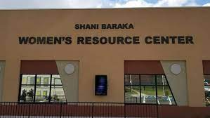

The Bridge (Health Minds, Healing Hearts, Peaceful Communities)
The Bridge is a nonprofit community-based organization that provides behavioral health care services designed to strengthen and support the family and to promote the personal growth of children, adolescents, adults, and families. Founded in 1971, we have a long-term commitment to helping children and families in the Caldwell’s, Irvington and greater Essex and Union counties to overcome mental health challenges that threaten to derail lives and tear families apart. Our vision is to promote balance, healing, and hope. In the last fiscal year, The Bridge served over 2,500 children, adolescents, adults, and families.

Outpatient Mental Health And Substance Use Counseling
With outpatient offices located in both West Caldwell and Irvington, The Bridge provides a stigma-free and culturally sensitive environment for children, adolescents, individuals, families and couples who are struggling to cope with life’s challenges. At The Bridge, everyone has an opportunity to receive the support they need to cope, grow, change and thrive. Prior to the COVID-19 Pandemic, people would typically come to The Bridge seeking help for anxiety, depression, mood disorder, loss, school refusal, trauma, life adjustments and transitions, substance use, gender identity, family conflict, parenting challenges and couples’ conflict. While we still continue to have clients with those issues, the additional stress of the COVID-19 Pandemic has become an overarching stress for many of our clients who have had to contend with the added worry of health safety, loss of loved ones, loss of previously enjoyed activities or a shift in future plans, economic challenges, food insecurity, and parenting or caregiving during remote learning. Our clinical staff, even while working remotely, and more recently a hybrid of in-person and remote, continues to take a systemic approach to treatment. Our clinical staff understands that honoring and supporting the importance of family/caregiver involvement offers the best support for our clients’ progress in treatment whenever possible and whenever appropriate to the client’s treatment goals. Over the course of the year our outpatient clinical mental health and substance use program has provided unduplicated services to approximately 520 clients. Our clinical staff provided 6165 mental health counseling sessions and 1899 substance use counseling sessions. Prior to the COVID-19 Pandemic, the average length of stay for our clients seeking mental health counseling was 3-6 months. However, over the last year many of our clients have wanted to maintain their connection to treatment in order to manage their stress. Consequently, the average length of stay for counseling has been 11 ½ months. Our services have always been in demand, but the demand has grown ten-fold over the last year. Due to telehealth restrictions for graduate mental health interns, we were not able to operate our intern program, which in the past had allowed us to serve more clients in the community. With our offices now open and operating in a hybrid fashion we have been able to restart our graduate intern program which allows us to expand our ability to serve the community. Additionally, we are actively looking to add seasoned clinical staff to provide services to the meet the needs of the community. During the last year, our substance use disorder program has gone through its own trauma as our Director of Substance Use Outpatient Services passed away due to COVID-19 in March 2021, causing a major trauma for our staff and clients. We supported one another and our community at large through this loss. In addition to the internal challenges of continuing to provide treatment during this sad time for The Bridge, many of the systems of care that provide referrals had also been shut down. However, during the spring of 2021 we were able to start re-opening our services to provide in-person drug screens and some in-person assessments and groups in addition the providing telehealth sessions. Our new Director of Substance Use Services, Tammy Nussbaum, joined our agency in May 2021 and has been a tremendous leader to our team as we continue to rebuild our program and have re-established ourselves through outreach to referrals and to the communities we serve.

School-Based Youth Services Program (SBYSP)/The Imani Center
The Imani (Swahili for Faith) Center is The Bridge’s comprehensive program for students at Irvington High School, located in the parking lot of the High School, as well as Making Achievement Possible, a program for middle school students at University Middle School, also in Irvington, NJ. During FY 2020-21, the Imani Center provided services to 385 students from Irvington High School and 187 students from University Middle School.

Counseling and Mental Health Services
- Individual, group, and family therapy sessions were provided virtually or in-person by qualified therapists addressing family conflict, academic issues, immigration issues, homelessness, depression, domestic violence, and general adolescent development issues for both high school and middle school students.
- Teen Strong, a Peer-to-Peer group, addresses how to avoid getting involved in human trafficking, unhealthy relationships, and rape.
- Express Yourself provided 6th and 8th graders virtual group sessions to build resilience and discover additional ways to cope with pain, isolation or anxiety that support healing.
- Men’s Group for high school students, provides a safe space for the young men to share their experiences, learn from each other and plan for better outcomes.
- 55 students participated in the Adolescent Pregnancy Prevention Initiative that encourages students to focus on dreams and goals to reduce the risks of pregnancy and sexually transmitted diseases.

COVID-19 Support
- Partnered with NJ Heroes Too to provide access to rapid, accurate diagnostics for Covid19 and the importance of testing. Served 150 families in Irvington.
- Developed and distributed art kits as Art for Healing, which provided students the opportunity to explore their emotions by increasing self-expression, developing skills that support resilience and discovering additional ways to cope with pain, isolation or anxiety that support healing.
- Computers donated by Novartis allowed youth to sign up for trainings, academic planning, and enrolling in New Jersey Career Assistance Navigator (NJ CAN).

Academic Support
- Collaborated with Irvington High School on Assist One, Keep One attendance group, part of a comprehensive, actionable, tiered approach to improving attendance.
- Academic Support/Tutoring helps students with homework and other school assignments on an ongoing basis, including three days per week for middle school students conducted by high school volunteers. Virtual sessions were offered during remote learning.
- Summer Enrichment Program focused on science, technology, engineering, and mathematics (STEM) and connections to everyday life. Middle school students took 16 virtual field trips during their four-week program.
- Entrepreneurship Program promotes entrepreneurial leadership, strategy, venture financing and startup skills.
- Translation services, provided in partnership with the Congregational Church of Short Hills, for Creole and Spanish speaking children, for the school and working with bilingual parents.

Community Engagement
- Community service projects, including crocheting blankets, valentine cards for veterans, assistance in the Irvington Court System, Township events, and more. Middle school students also volunteered at the Community Food Bank of New Jersey.
- The Our Voice Matters Campaign grew out of the effort to remove funding for the School Based Youth Service Programs from the state budget. Students rallied to support the Imani Center in September 2020. Once funding was restored, students continue to advocate on topics important to them through a weekly podcast available on the Imani Center’s multiple social media platforms (Facebook, Instagram, Twitter, and theimanisafespace.com).
- 8 teens who are about to age out of the foster care system participated in the Independent Living Program, learning life skills such as money management, food shopping and cooking, health education, employment resources and/or access to vocational training or college. Ninety percent of the teens reached all their goals for the program.
- Partnered with Helen Keller International to provide a space to offer FREE vision screenings and glasses 8-15 years old Essex County residents.
- Selected staff participated in Trauma-Focused Cognitive Behavioral Therapy (TF-CBT) training to become certified.
- Assisted in Essex County Trauma Loss Coalition (TLC) Crisis team and are becoming active member of the TLC.
- Partnered with New Jersey Association of Mental Health & Addiction Agencies, Inc. (NJAMHAA), and the Attorney General’s Directive, known as the “Handle With Care Directive” to provide additional resources and be advocates in the community.
- Facilitated a Uniform giveaway to 67 students in need to ensure school participation

The Peace Model Project
The Peace Model Project (PMP) is an elementary school-based counseling and intervention program developed by The Bridge and the Caldwell-West Caldwell School district. PMP was launched in 2015 through a three year (2015-2018) national funding initiative of the US Department of Education in response to the Sandy Hook school shooting in 2014. Building on an existing 45-year partnership between The Bridge and the Caldwell-West Caldwell School District, PMP developed a multi-tiered school-based counseling program in the four elementary schools in the district. The Peace Model Project seeks to change the culture within the elementary schools to reduce the stigma around mental health care by infusing practices that promote resiliency within the school setting. The Bridge embedded Peace Model Counselors in each of the schools, allowing them to be fully integrated partners who are part of the fabric of the school community. During this year of unprecedented challenges for schools across the nation, the PMP team made an enormous impact in the Caldwell-West Caldwell school community – providing one-to-one counseling support to 20% of the total elementary student body. In addition, 5% of the elementary families were connected through PMP to outside mental health providers (including The Bridge). Eleven percent of the elementary students were able to join support groups around anxiety and social skills development – an exceptionally high number considering that these groups had to occur on virtual platforms after school dismissal. Over the course of the school-year, eight customized lessons were created and presented to 1,146 students (grades K-5) on such topics as Dealing with Disappointment, Coping with Change, Coping with Stress, Listening with My Heart (Self-Compassion), Staying Hopeful, Keeping Motivated, & Making Friends. Parents/caregivers received outreach via virtual newsletters to connect them to the support that their students were receiving and to the wider community support programs available through The Bridge and throughout Essex County. Over 20% of parents/caregivers received individual guidance, coaching or support from The Bridge’s PMP counselors during this school-year. Many attended a parent education seminar called “Self-Compassion: For Parents” presented by the Peace Model Project. Lastly, we are proud of the fact that over 75% of in-district teachers received consult and collaboration from their PMP counselor about how to best meet the needs of specific students who were struggling with challenges like social isolation, family stress, uncertainty and loss.

Family Preservation Services
Family Preservation Services (FPS) is an intensive, in-home crisis intervention and family education program for families whose children are at imminent risk of abuse, neglect, or out of home placement, and for families preparing to be reunified with their children. The Bridge’s highly trained and dedicated staff is available to each family 24 hours a day, 7 days a week for up to eight weeks. Families throughout Essex and Union Counties are provided with 5 to 20 hours of direct face-to-face services per week. The intensive skill-based intervention includes a minimum of three home visits per week where staff teaches families a variety of skills which includes parenting, stress management, coping, communication, and anger management. The goal of FPS is to keep children safe, stabilize the family, prevent out-of-home placement, improve family functioning, and link families with appropriate community resources. All services are designed to build on family strengths. This year, Family Preservation Services assisted 76 families, including 188 children, who were referred by the Child Protection and Permanency local offices. Among those families:
- Forty-four percent achieved their case goals
- Thirty-one percent significantly achieved their case goals
- In Essex County, 94% of children remained with their families in the six months following completion of the Family Preservation Services program.
- In Union County, 100% of the children remained with their families in the six months following completion of the Family Preservation Services program.
During this fiscal year, the FPS program demonstrated flexibility in the delivery of services in response to the pandemic of COVID- 19. During the week of July 13, 2020, at the direction of Department of Children and Families (DCF) leadership, FPS returned to the field using a hybrid approach that included a combination of in-person contacts and telehealth sessions. During October 2020, FPS began to provide a combination of in-home, in-person, and telehealth sessions. In December 2020, DCF issued new guidance with instruction for a full return to the field to provide in-home sessions. The Bridge continued to make telehealth sessions available for situations where there was possible risk of exposure to COVID-19. Families have continued to receive quality-based services throughout all phases of adjustment in the delivery of services.

Stepping Stones
The Stepping Stones Women with Children program provides substance use disorder treatment to women with children that are involved with New Jersey’s Department of Child Protection and Permanency (DCP&P). The program also accepts women of childbearing age that are not involved with DCP&P. The women are from Newark, Irvington, Maplewood, East Orange, and West Orange and sometimes from Middlesex and Ocean Counties. The women’s commonality is that they are pregnant, recently gave birth or have children or are caring for children and are experiencing a substance use disorder. Through the use of didactic individual and group sessions, psycho-education is provided to increase the knowledge of the negative impact of substance use on family dynamics, the developing fetus, the brain, the inability to effectively parent, and the poor decision making and poor coping mechanisms that are part of the substance use cycle. The women are introduced to prosocial, peer support recovery systems and mutual support groups to increase their exposure to positive reinforcement for abstinence and recovery-based living. COVID -19 greatly impacted our very successful Stepping-Stones Women’s program. Because of the pandemic, we were forced to shut down all in-person services from March 2020 until June 2021. Many of our supporting programs in the community also were closed during this time. Our food and child supplies and contributions were also greatly diminished and our women, who mostly have young children and/or DCP&P services, were left with limited support during a difficult time. However, at The Bridge, we worked to provide the best services we could during these challenging times. We continued to offer Intensive Outpatient Services which included individual and group counseling sessions via telehealth. Our counselors and administrative team were available and on call for women who faced struggles and challenges alone during this health crisis. The Bridge offered support any way it could through discussion, referrals, and outreach. The Stepping Stones Coordinator has continued our efforts to conduct outreach to neighboring agencies in Irvington and the surrounding towns for donations and contributions of food, baby supplies, holiday gifts, gift cards and more for women, their children and families. One such agency, Flames of Giving, has already made many extremely generous donations to assist and support these women. Their generosity and cheerful outlook have greatly helped these women with items they would not otherwise be able to afford. Another agency that has worked closely with The Bridge is Partnership for Maternal and Child Health of Northern NJ. This agency engages the women in education about addiction and pregnancy. It also lends support and provides advocacy to the women within our community. The Stepping Stones program continues to offer the support and encouragement needed for these women to succeed without being dependent on alcohol and or illegal substances. In these trying times, The Bridge continues to assist these women through various psychosocial and didactic groups and individual counseling to strive to achieve overall success and independence.

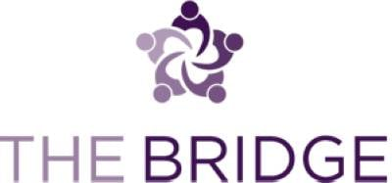

West Caldwell Outpatient Services:
860 Bloomfield Avenue, West Caldwell, NJ 07006
Phone: (973) 228-3000

Irvington Outpatient Services / Stepping Stones:
50 Union Avenue, Irvington, NJ 07111 (Suite 306)
Phone: (973) 372-2624

Family Preservation Services:
50 Union Avenue, Irvington, NJ 07111 (Suite 305)
Phone: (973) 371-3771

Imani Center / MAP:
1253 Clinton Avenue, Irvington, NJ 07111
Phone: (973) 399-7797

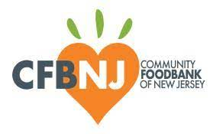

The Community Food Bank of New Jersey
The Community FoodBank of New Jersey (CFBNJ), a member of Feeding America®, is the leading anti-hunger and anti-poverty organization in the state. What started as a modest enterprise in the back of our founder Kathleen DiChiara’s station wagon in downtown Newark in 1975, became an incorporated non-profit in 1982 and has grown to two warehouse facilities in Hillside and Egg Harbor Township, the combined size of five football fields. These locations serve area programs and community partners – over 800 in 15 of 21 New Jersey counties.

How CFBNJ Helps Hungry Neighbors
We package food orders for local soup kitchens and food pantries; we purchase and collect food for distribution; help people in need through SNAP application assistance; reach communities with limited resources with mobile pantries; and encourage others to get involved. Last year, we distributed food for over 86 million meals (more than 103 million pounds), 34% of which was fresh produce. We address hunger as a health issue by providing more fruits and vegetables, nutrition education, and medical screenings to inspire positive lifestyles. Community members from all walks of life engage in our mission through volunteer opportunities resulting in over 27,000 volunteer visits last year-equivalent to the work of about 31 full-time employees.
CFBNJ’s mission is to fight hunger and poverty in New Jersey by assisting those in need and seeking long-term solutions. We will engage, educate and empower all sectors of society in the battle. We advance this mission during times of relative calm and during periods of upheaval. We are so grateful for your support in this fight.

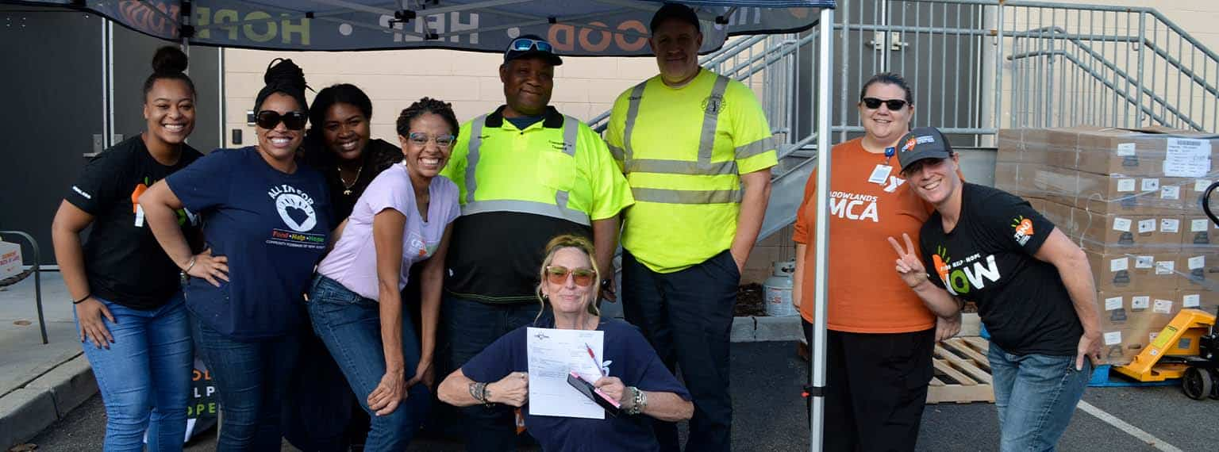

Headquarters31 Evans Terminal
Hillside, NJ 07205
908-355-3663

Southern Branch
6735 Black Horse Pike
Egg Harbor Twp, NJ 08234
609-383-8843

The Salvation Army
Its founders sought to bring salvation to the poor, destitute, and hungry by meeting both their "physical and spiritual needs". It is present in 133 countries, running charity shops, operating shelters for the homeless and disaster relief, and humanitarian aid to developing countries.

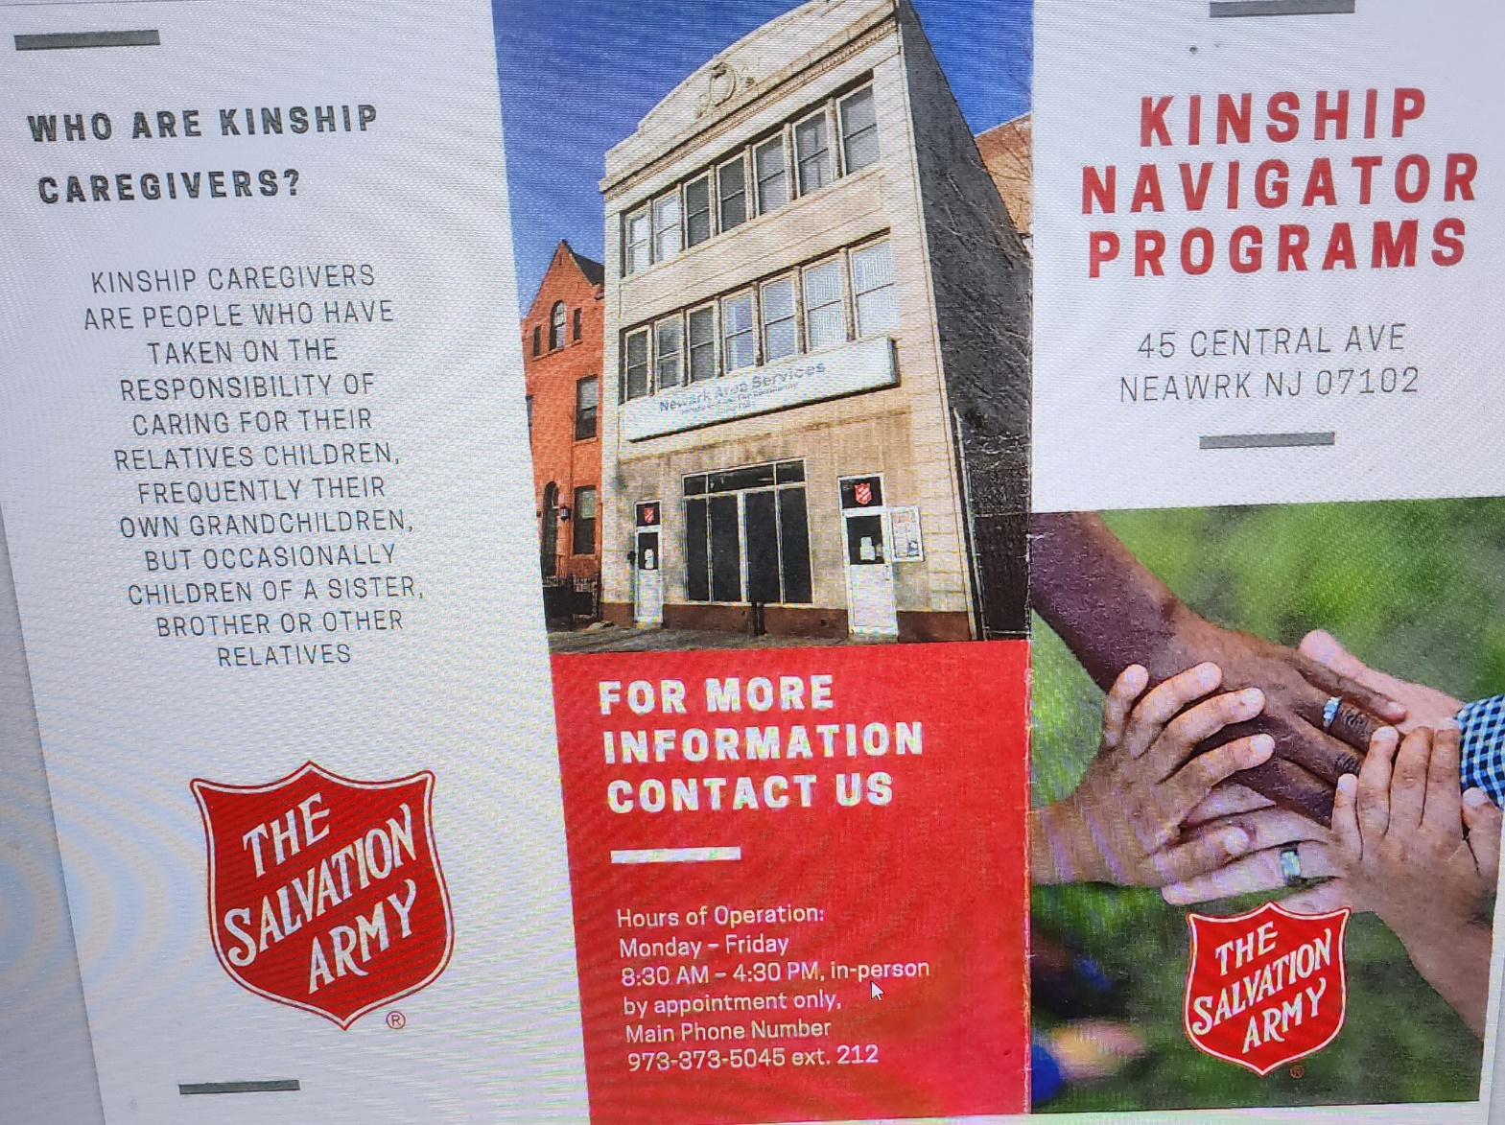

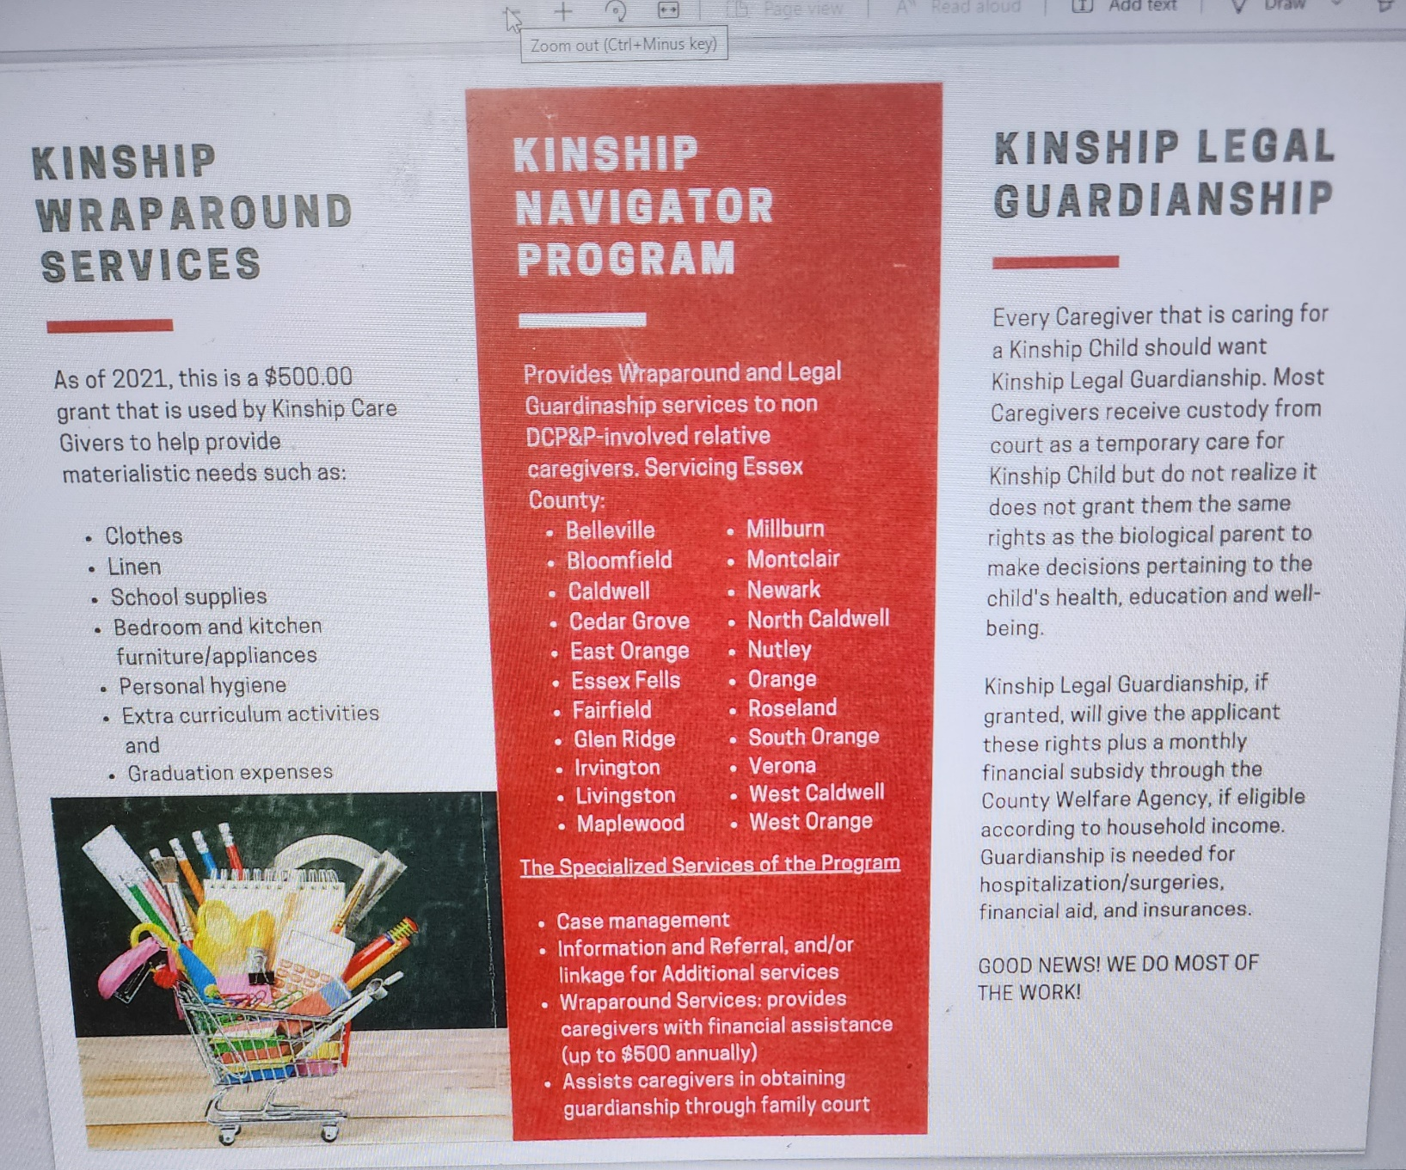

Address: 45 Central Ave, Newark, NJ 07102
Hours:
Open ⋅ Closes 4PM
Phone: (973) 623-5959

Address: 74 Pennington St, Newark, NJ 07105
Hours:
Closed ⋅ Opens 10AM
Phone: (800) 728-7825

Address: 138 Clifford St, Newark, NJ 07105
Hours:
Closed ⋅ Opens 11AM
Phone: (862) 373-1942

Housing Assistance
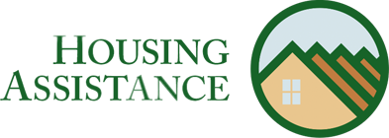

Emergency Rescue Mortgage Assistance Program (ERMA)
The New Jersey Housing and Mortgage Finance Agency (NJHMFA)'s Emergency Rescue Mortgage Assistance Program will provide up to $75,000 in assistance to cover mortgage payments, delinquent property taxes, and other housing cost delinquencies for eligible homeowners negatively impacted by the COVID-19 pandemic. To be eligible, you must be a New Jersey homeowner with a demonstrated COVID-19-related financial hardship, own and occupy an eligible primary residence, were current on mortgage and property taxes as of January 2020, and have an income below 150% of their Area Median Income. You can apply through the application portal or contact the NJ ERMA team at 855-647-7700.

County and City Rental Assistance Programs May Help
Atlantic County - Atlantic County's Short-Term Emergency Mortgage Assistance Grant Program provides temporary mortgage assistance up to $10,000 for low- and moderate-income households in Atlantic County that were financially impacted by the COVID-19 pandemic. Learn more about eligibility requirements and the application process.
Bergen County - Bergen County has an Emergency Rental and Utility Assistance Program available for eligible residents who experienced financial hardship due to COVID-19. This program will pay up to 15 months of owed back rent and utilities starting from March 2020. Learn more about eligibility requirements and the application process.
Burlington County - The Emergency Mortgage and Utility Assistance program of Burlington County provides Burlington County homeowners with financial hardships due to the COVID-19 pandemic with up to six months of mortgage and/or utility assistance. Learn more about eligibility requirements and the application process.
Cherry Hill Township ONLY - The Cherry Hill Rental and Mortgage Assistance Program provides up to six months of mortgage and rental assistance for low- and moderate-income households that were
financially impacted by the COVID-19 pandemic. Learn more about eligibility requirements and the application process.
Essex County - Essex County Emergency Rental Assistance Program is offering eligible applicants money to pay rent or utility bills for those affected by COVID-19. The application can be found here.
East Orange ONLY - COVID-19 Rental Assistance Grant Program Phase II provides up to $6,000 for up to six months of rent in arrears. Applications can be submitted at the following agencies: Isaiah House ((973) 678-5882 ext.3020 or rentalassistance@isaiahhouse.org), East Orange Community Development Center ((973) 266-5347 or eastorangecdc@aol.com), or NJ SHARES (eastorange@njshares.org). Applications will close on December 31, 2022.
Gloucester County - Gloucester County's Emergency Rental and Utility Assistance Program
provides up to 18 months of financial assistance toward unpaid rent and/or utility bills for low- and moderate-income renters in Gloucester County who have been financially impacted by the COVID-19 pandemic. Learn more about eligibility requirements and the application process.
Hudson County - Hudson County's Emergency Rental Assistance program provides back rent and utility assistance to households that have fallen behind as a result of the COVID-19 pandemic. Applicants must be a resident of Hudson County with the exception of Jersey City residents. Learn more about eligibility requirements and the application process.
Hunterdon County - Family Promise of Hunterdon County is offering assistance to residents who are currently in rental arrears due to loss of income as a result of the COVID-19 pandemic. For more information on the eligibility and the application process call (908) 782-2490.
Mercer County - Mercer County's Emergency Rental Relief Program provides financial assistance with unpaid and future rent of utilities of households that have been financially impacted by the COVID-19 pandemic. Learn more about eligibility requirements and the application process.
Middlesex County - Middlesex County's Emergency Rental Assistance Program provides financial aid to renters that are behind on rent and/or utility payments as a result of the financial impacts of the COVID-19 pandemic. Learn more about eligibility requirements and the application process.
Edison ONLY - The Township of Edison has allocated $1,000,000 of its federal Community Development Block Grant CARES Act Funds towards the creation of an Emergency Rental and Mortgage Assistance Program. This can provide assistance for up to six months in arrears of housing costs for low- to mid-income households at or below the 80% Area Median Income. To find out more information and how to apply, click here.
Morris County - Morris County's Rental Assistance program provides renters who have been financially impacted by the COVID-19 pandemic with financial assistance on past, current, and future rents. Learn more about eligibility requirements and the application process.
Passaic County - Funds are currently unavailable, but residents are still encouraged to ing residents to fill out an application. Passaic County’s Passaic Housing Security Initiative and Emergency Rental Assistance Program provides up to $20,000 for overdue rent for renters who have been financially impacted by the COVID-19 pandemic. Learn more about eligibility requirements and the application process. (Spanish information). Passaic County is also now offering a resource hub for social and human services to their residents.
Somerset County - The Emergency Rental Assistance Program application is currently closed, but residents can sign up to receive updates as more funding may be received in the future.
Union County - The Urban League of Union County, Inc. provides rental and mortgage assistance. Learn more about eligibility requirements and the application process.
Union County also offers the Emergency Rental Assistance Program. This program provides financial assistance with past-due rent and utility payments for Union County renters who have been financially impacted by the COVID-19 pandemic. Learn more about eligibility requirements and the application process.
Learn about other homelessness prevention programs across New Jersey by searching our resource database.

Tenants Know your Rights
From March 1, 2020, to December 21, 2021, there was an eviction moratorium during the COVID-19 Emergency which prevented renters from being locked out of their homes until after that time. While the eviction moratorium was in effect, renters had certain rights. The Community Health Law Project, offers a simple summary of what you can expect and on other topics.
NJ Courts also recorded and posted a webinar detailing Landlord/Tenant Legal Information regarding eviction matters. Legal Services of New Jersey's has a monthly newsletter about housing updates, policies, and more.

Free Counseling Available to Homeowners and Renters
Governor Murphy and Housing and Mortgage Finance Agency (HMFA) announced an expansion in the NJ HMFA's Housing Counseling Initiative during the pandemic. Now free assistance is available from housing counselors to help homeowners going through foreclosure, which includes pre-foreclosure and rental assistance counseling. Even families that are receiving some sort of relief are expressing concern at their ability to make back payments on rent, mortgages, property taxes, etc. A housing counselor can help you understand what sort of relief is available for your situation and build an action plan to get you to the other side of this crisis with your best possible outcomes. You may also seek help through this program by calling 800-654-6873.
Help for Homeowners - Counselors will provide an analysis of the client’s financial situation; evaluation of the current value of the home that is subject to the mortgage; review of options such as lender in-house modifications that may include restructuring or refinancing strategies; and the approval of an action plan by all interested parties. In the case of foreclosure prevention, whether or not the homeowner is in foreclosure, the goal is to assist the homeowners in retaining their homes with an affordable mortgage, however this result cannot be guaranteed in all situations and some instances may require assisting with a soft transition. Learn more about help for homeowners here or here.
Help for Renters - Counselors will provide an analysis of the client’s financial situation, and guide tenants through budget and credit repair, assist with fair housing issues, and eviction diversion and transition, if necessary. Learn more about help for renters here.

Housing Help NJ
Housing Help NJ is a program that is administered through the Housing and Community Development Network of NJ. It was developed to connect New Jersey renters, landlords, and homeowners to assist in preventing eviction. If you would like to speak with someone about foreclosure or eviction, call 888-691-3002. Housing Help NJ does not provide direct financial assistance.

RELATED PAGES

Rent Registration
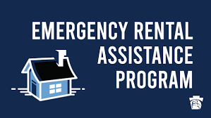
The office of Rent Control assists landlords and tenants in understating the impact the Municipal Rent Control Ordinance of the City of Newark, may have on their properties and apartments. Technical assistance is provided on a wide variety of rental issues which cover such matters as: which apartments are subject to local rent control laws; what is the legal base rent; what rent increases the law permits; tax surcharges ;water/sewer surcharges; major new improvement surcharges; hardship increases; and annual registration requirements. Files on all residential properties are maintained for public inspection if owners and/or tenants have questions regarding a particular property.
‍

WHAT WE DO AND DON’T DO
The Newark Rent Ordinance regulates rents for certain residential rental units in Newark, New Jersey. There is no commercial rent control in Newark.
The Rent Control Board’s primary function is to conduct hearings and mediation of tenant and landlord petitions regarding the adjustment of rents under the City’s rent control laws.
The Rent Control Board cannot arbitrate matters that are not part of the Title 19, Chapter 2, Rent Control Regulations, Rent Control Board, of the Revised General Ordinances of the City of Newark. For example, we do not have jurisdiction to adjudicate alleged breaches of a rental agreement, which must be decided in court. The Rent Control Board also cannot hear cases concerning issues of discrimination, harassment or retaliation, as such matters are outside of our jurisdiction. Please contact the Department of Community Affairs regarding these issues.
The Rent Control Board provides counseling information on subjects that are covered by the Rent Ordinance ONLY. Please understand that our staff CANNOT give legal advice and they are instructed to let you know when your question is one that should properly be answered by a lawyer.
While we cannot refer you to individual attorneys, our staff will be glad to direct you to the appropriate resources for advice and assistance. A list of these resources is available through the referral listing on our website. Please note that you do not need a lawyer to file a petition at the Rent Control Office.
Due to high demand and a limited number of staff, there can sometimes be delays in speaking with a representative. It is helpful if you have your questions written down before you speak with a representative.

INFORMATION
Economic and Housing Development
Office of Rent Control
‍
Rent Regulation Officer
920 Broad Street
Room 111
Newark, NJ 07102
Phone: 973-733-3675
Fax: 973-733-6366
Email: rentcontrol@ci.newark.nj.us
Get in Touch

OFFICE HOURS:
Hours: 8:30am - 4:30pm
Program for Parents

Programs for Parents (PfP) is a non-profit organization which works to ensure that children get the best possible start in life. We accomplish this by promoting quality child care services within our community.
We link families seeking child care with those organizations that provide such resources. In addition, our goal is to continue to enhance the skills and activities of child care providers so that children and families receive high quality services in the areas of health, safety and child development.

FAMILIES

Ensuring That Children And Families Receive High Quality Services In The Areas Of Health, Safety And Child Development.
As the Child Care and Resource Referral Agency for Essex County, Programs for Parents (PfP) offers resources, professional skills and experience to develop and implement an ever-growing range of services to meet the needs of families in our community.

CHILD CARE PROFESSIONALS

Programs For Parents trainers have all met the Approved Trainer qualifications required for the Professional Impact New Jersey Registry by the NJ Workforce Registry.
Evidence shows that the developmental needs of a child (such as academics, social, emotional and physical) require professionals who have earned credentials in their field. Programs for Parents’ trainers help early childhood professionals achieve certification that acknowledges their skills in early childhood development. In addition, our trainers provide ongoing training to refresh and expand their knowledge in this evolving area.
Training is available to meet the needs of staff at all levels, from entry level to executive.
Programs For Parents trainers have all met the Approved Trainer qualifications required for the Professional Impact New Jersey Registry by the NJ Workforce Registry www.njccis.com.

We Will Do It Together!
Programs for Parents is here to serve the Essex County and broader child care community. We provide education, training, referrals and resources in Newark and beyond. We also partner with other non-profits, governmental agencies, local businesses, schools and families to educate and enrich our community. To see the full range of training, information and services we provide, please browse our menu options above.
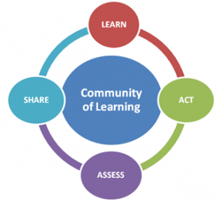
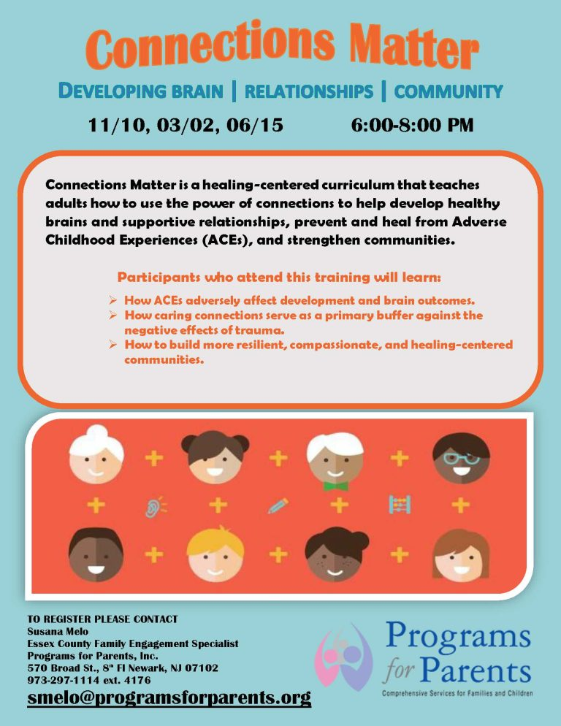
LIHEAP
If your service is currently at risk of being shut off, you must notify us that you have applied for payment assistance. This will protect you from service disconnection while your application is being processed. Please email vouchers@pseg.com and provide the following information:
- Your account number
- The name of the assistance program to which you applied
- How you applied and either the confirmation number or the agency name

American Rescue Plan (ARP)
The American Rescue Plan (ARP) is now offering financial assistance to help customers pay past-due gas and electric bills, even if you already receive assistance. The application process is simple and no documentation is required.
- To apply, call 609-984-6670 or visit NJ Department of Community Affairs.
LIHEAP
The Low Income Home Energy Assistance Program (LIHEAP) helps low-income residential customers pay for heating and cooling bills, even if heat is included as part of rent payments. LIHEAP may also provide emergency assistance funds during certain times of the year.
To qualify, your household income cannot exceed the amounts noted in the LIHEAP household income table:
Household Size | Maximum Gross Monthly Income
1 | $3,464
2 | $4,530
3 | $5,596
4 | $6,662
5 | $7,728
6 | $8,794
7 | $8,994
8 | $9,193
9 | $9,393
10 | $9,593
11 | $9,793
12 | $9,993
Amount for each additional member  for households greater than 12 | $200
LIHEAP accepts applications from October 1st to June 30.
PSE&G heating customers usually receive an average of $300 towards their energy bill, and about $200 for medically necessary cooling, if qualified.
The application options are listed below:
- Apply online here.
- Download an application to submit to the Intake Agency your county via mail, fax or email with all the required documentations.
- Pick up an application at one of the PSE&G’s Customer Service Centers during operating hours.

For more information, visit NJ Department of Community Affairs Energy Assistance, or call 1-800-510-3102, 7 days a week, 9 a.m.- 9 p.m.

New Jersey Universal Service Fund (USF)
The New Jersey Board of Public Utilities created the Universal Service Fund (USF) to help make energy bills more affordable for customers. If you're eligible, USF can lower the amount you have to pay for your gas and electric bills.
You may be able to receive from $5 to $180 per month toward your gas and electric bills.
To qualify, your household income cannot exceed the amounts noted in the USF household income table:
Household Size | Maximum Gross Monthly Income*
1 | $4,530
2 | $6,103
3 | $7,677
4 | $9,250
5 | $10,823
6 | $12,397
7 | $13,970
8 | $15,543
9 | $17,117
10 | $18,690
11 | $20,263
12 | $21,837
Amount for each additional member  for households greater than 12 | $1,574
Note: If you apply for LIHEAP you are applying for USF since one application serves for both programs.
USF applications are accepted any time of the year.
The application options are listed below:
- Apply online here.
- Download an application to submit to the Intake Agency your county via mail, fax or email with all the required documentations.
- Pick up an application at one of the PSE&G’s Customer Service Centers during operating hours.

For more information, visit NJ Department of Community Affairs Energy Assistance, or call 1-800-510-3102, 7 days a week, 9 a.m.- 9 p.m.

New Jersey Lifeline for Seniors and Disabled Adults
New Jersey Lifeline is a $225 yearly electric or gas bill credit for seniors or disabled adults in New Jersey.
To qualify, you must be a New Jersey resident, 65 years of age or older, or 18 years of age or older and receiving Social Security Title II Disability benefits.
Your personal annual income (not the household income), cannot exceed $28,769 if single or $35,270 if married.
To learn more, see NJ Lifeline or call the New Jersey Department of Human Services Division of Aging at 1-877-222-3737. To apply now online visit: www.aging.nj.gov. This program is available year-round.

NJ 2-1-1 Partnership
If you continue to need utility assistance, please contact 2-1-1 or click nj211.org.

